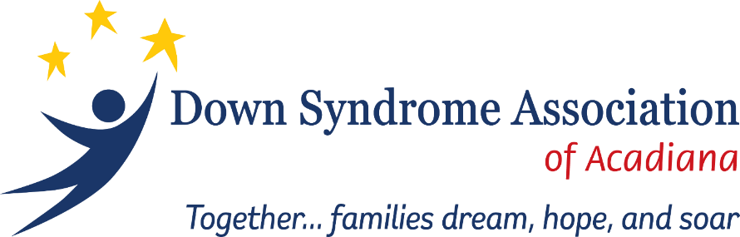

**2024 DSAA BUDDY WALK®**

**SPONSORSHIP OPPORTUNITIES**

**20th Annual Buddy Walk**

**October 26, 2024**

**Parc International**

**Lafayette, Louisiana**

##### Buddy Walk®

Down Syndrome Association of Acadiana (DSAA) hosts an annual Buddy Walk®, Acadiana’s only event celebrating all individuals with Down syndrome. Join us as we unite for a common cause and raise funds at the 2024 DSAA Acadiana Buddy Walk®. We attract over 1,000 participants and volunteers who walk the 1-mile course. Immediately following the walk there will be food, activities, and live music entertainment for the whole family. Whether you have Down syndrome, know someone who does, or just want to show your support, take the first step, and donate or register today! Help us spread the word. All are welcome for our day of celebration! Join us for the 20th Annual Buddy Walk® and help us assist families with Down syndrome.

##### Your Direct Impact

DSAA’s mission is to provide information, advocacy and support concerning all aspects of life for individuals with Down syndrome, their families, and our community. Through our many programs and events, DSAA has served over 200 plus families throughout our 7-parish service area and throughout the state of Louisiana. Since our inception in 2004, DSAA has remained consistent in generating acceptance and belonging of individuals with Down syndrome. We provide our families with benefits such as our stipend program, college scholarships, workshops and seminars, group events, national conference trips and much more.

##### We are a self-funded non-profit

DSAA does not receive any governmental funding or money from any national Down syndrome organization. We rely on the generosity of our community and through fundraisers such as Buddy Walk® to allow us to continue meeting the many needs of our members.

DSAA BUDDY WALK®: **2024 SPONSORSHIP LEVELS**

|  |  |  |  |  |  |
| --- | --- | --- | --- | --- | --- |
| **SPONSORSHIP BENEFITS** | Gold  $3,000 | Silver  $2,000 | Bronze  $1,000 | Buddy  $500 | Route  $250 |
| **CORPORATE VISIBILITY** |  |  |  |  |  |
| Recognition on signage displayed throughout the event | LOGO | LOGO | LOGO | LOGO | LOGO |
| Recognition on DSAA Buddy Walk® website | LOGO | LOGO | LOGO |  |  |
| Recognition on DSAA Buddy Walk® Facebook page | LOGO | LOGO | LOGO |  |  |
| Acknowledgement in advertising | LOGO | NAME | NAME |  |  |
| Event posters distributed throughout Acadiana: 250 | LOGO |  |  |  |  |
| Recognition on back of approximately 2000 event t-shirts | LOGO | LOGO | LOGO | NAME |  |
| Complimentary event t-shirts | 8 | 6 | 4 | 2 | 1 |
| Complimentary event registration | 8 | 6 | 4 | 2 | 1 |
| Company listed in post-event Thank You Ad | NAME | NAME | NAME | NAME | NAME |
| Custom printed signage along walk route |  |  |  |  | LOGO |

|  |
| --- |
| **For additional information regarding sponsorship opportunities** |
| Visit our website at www.DSAABuddyWalk.com |
| Contact Carmen at 337-234-3109 or email: [dsaa@dsaa.info](mailto:dsaa@dsaa.info)  Clouviere@dsaa.info |
| Register to become a sponsor on our website: www.DSAABuddyWalk.com |
| Learn more about our organization at dsaa.info. Your support is greatly appreciated! |

|  |
| --- |
| **Four ways to become a sponsor** |
| Financial donation |
| In-kind donation |
| Form a corporate Buddy Walk® team |
| Any combination of the above options |

*All benefits are limited to 1 company logo or name.*

**Sponsor Deadline:** *To receive all sponsorship benefits, sponsor registration form must be received by* ***October 2, 2024.***

**Join us for a day of fun!**

Parc International comes alive every year on the last Saturday of October as we host our annual Buddy Walk®. Members, along with their family and friends, join us as we celebrate one another and walk one mile through downtown Lafayette. Everyone returns to Parc International and has a day filled with great music, dancing, food, plenty of arts and crafts and activities for all ages.

**Make An Impact**

Please take this opportunity to review our sponsorship opportunities. By becoming a sponsor, you will help national and local initiatives to empower families and people with Down syndrome through information, education, and social activities. Thank you for your consideration. Many sponsors use the event to build employee morale and create community good will. ***Register your team at*** **www.DSAABuddyWalk.com *and join us for 20th Annual Buddy Walk®!***



**SPONSOR REGISTRATION**

**To receive all sponsorship benefits, this sponsor form must be received by October 2, 2024.**

Company/Sponsor Name: Contact Name: Address: City: State: Zip: E-mail (*required*): Phone: ( ) Fax: ( )

**SPONSOR AMOUNT METHOD OF PAYMENT**

|  |  |  |
| --- | --- | --- |
| **Your partnership is sincerely appreciated. By execution of this form, you are affirming your participation as a sponsor at the above-indicated level. NOTE: Signing this form gives Down Syndrome Association of Acadiana and its agents permission to use images, electronic or photographic, in future promotional materials.** | Gold $3,000 (select 8 shirt sizes)  Silver $2,000 (select 6 shirt sizes)  Bronze $1,000 (select 4 shirt sizes)  Buddy $500 (select 2 shirt sizes)  Route $250 (select 1 shirt size)  In-Kind $_____________  Description __________________________  **Sponsor Representative ___________________________________** | Please enclose checks made payable to  DSAA, Post Office Box 81323, Lafayette, LA 70598.  DSAA is a non-profit 501(c)3 organization; your donation is tax-deductible. QUESTIONS? [dsaa@dsaa.info](mailto:dsaa@dsaa.info)  337-234-3109  **Date ____________________________**  **Date ____________________________**  **Please send your high-quality logo (if applicable) via e-mail to dsaa@dsaa.info as soon as your sponsorship is submitted.**  **THANK YOU FOR YOUR SUPPORT OF DSAA!** |

**Adult T-Shirt Sizes**

**Children’s T-Shirt Sizes**

Small

XXXL

XXL

XL

Large

Medium

Down Syndrome Association of Acadiana |P.O. Box 81323 | Lafayette, LA 70598 | 337-234-3109 | www.dsaa.info

XS:__

XXXL:__

Large:__

XL:__

Med:__

XXL:__

Small:__

Med:__

Large:__

Small:__